**Project Plan: ACL Rehabilitation App for Side Hop Jump Classification**

**Background**

The Anterior Cruciate Ligament (ACL) is a major stabilizing ligament in the knee. ACL injuries are common in sports and activities involving sudden direction changes or pivots. These injuries can cause knee instability and often require a structured rehabilitation process, focusing on exercises to restore knee stability and movement control. Accurate execution of these exercises, such as the side hop jump, is essential for recovery and to prevent re-injury. In the U-Motion laboratory at Umeå University, we have captured movement patterns from a set of individuals including injured and non-injured athletes and controls. Measuring in a high-tech laboratory generates accurate data but can be cumbersome because people have to find time to come to the lab and staff have to operate the system. Therefore, it is desirable to move the measurement to the individuals themselves and let them do the measurement and get feedback from a mobile application.

 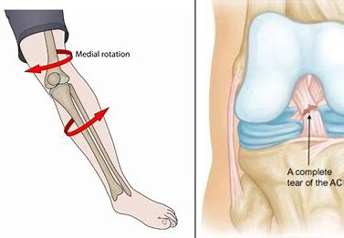 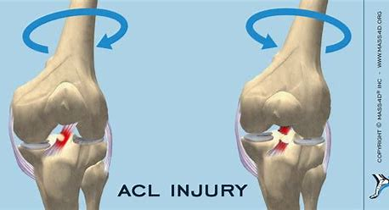

**Project description**

This project aims to start the transition to a mobile/home application. Firstly, implement backend data analysis using machine learning to classify/rank individuals and their movement patterns based on side-hop measurements. Data will be provided from U-Motion laboratory that contains a range of movement patterns, from good to less desirable (Good or Proper movement, happens when the hip, knee, and foot are all in perfect alignment, forming a straight line, on the other hand, Improper movement occurs when the hip, knee, and foot are not aligned in a straight line, resulting in an angled position..). Secondly, design and implement a user interface, preferable cross-platform/web application, meant to be used at home by a patient for self-assessment during rehabilitation. The application shall have a future prof design that incorporate easy input of patient information, accept measured data (simulate a measurement), store data and results, and give relevant feedback to the user in an intuitive way.

